Peter King – A neglected figure in ’50s British Sculpture

Published in Sculpture Journal, Vol. 18.1, 2009, pp. 100-111
By Mike King

In his short life, from 1927 to 1957, Peter King completed a prodigious quantity of sculpture and works on paper. His trajectory moves, after study at Wimbledon School of Art, from ‘academic’ sculptural works and public monumental commissions, through very contemporary forms of abstraction, to a quite destructive fluidity of form in his last months. After the chaos of his last few years he left behind a widow with two children and a mistress and son, who between them kept safe a significant proportion of his collection. Many works had been sold to private collectors, and to the Arts Council, the British Council, and the Contemporary Arts Society. Many more works were destroyed, the bulk of these scattered in the grounds of the seminal Abbey Art Centre artists’ commune in High Barnet, London, which either rotted away, were stolen, or – quite probably – landed up on the popular 5th November communal bonfire. King as an artist largely disappeared from public and critical view after his death.

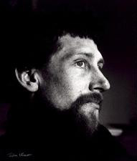 | Fig. 1  Portrait of King by Ida Kar, in the National Portrait Gallery. This was probably taken not long before his death.  Photographer: Ida Kar  Copyright: National Portrait Gallery

It is only recently, with archival material emerging from private sources, and from archives at TateBritain and the Henry Moore Institute, Leeds that the true picture of King’s place in British art of the 1950s is beginning to emerge. The Henry Moore Institute has a collection of Peter King memorabilia, donated, along with several of his works, by his widow in 2002, while the British Museum recently purchased several works on paper. Scholarly interest is growing, and his name has appeared in recent publications. In 2003 the Museum of London showed his film The Thirteen Cantos of Hell, as part of a celebration of London artists’ quarters, and King is mentioned in the accompanying book. In 2004 Ian Barker, having drawn on the Henry Moore Institute archive, made eight references to King in his volume on Anthony Caro, and in 2007 there were three references in a Henry Moore Foundation book on Hoglands. Most notable to date is the essay by Martin Harrison in the Henry Moore Institute 2003 two-volume series on British sculpture. In it Harrison describes King’s early monumental work for Giudici stone-carvers, his appointment as assistant to Moore, his first one-man shows at Gallery One, and the final anguished, dripped and spattered head-forms created shortly before his death. Exhibitions including works by King are now taking place on a regular basis.

As noted by the Museum of London, King was embedded in Soho, the creative quarter of London in the 1950s. Through its galleries, through St Martin’s where he taught from 1953, and through his employment at Moore’s Much Hadham studios, he came to know many of the key artists, curators, and collectors of the time. He knew the artists of the New Aspects of British Sculpture pavilion at the 1952 Venice Biennale. This is remembered in terms of Herbert Read’s catalogue essay, which introduced the term ‘the geometry of fear’, a term that might usefully be applied to some of King’s work. In a private letter Frank Martin, who hired King to teach bronze-casting at St Martin’s, said that King ‘stood alongside the rest of my team at that time, all emerging sculptors: Caro, Paolozzi, Frink and Clatworthy.’ At Hoglands, Moore’s home and studio, King worked with Caro, Alan Ingham and Peter Atkins. One of the major projects that he worked on was the far-right of four enormous stone elements in Moore’s Time-Life screen (former Time Life Building, Bond Street, London, 1952-3), as part of a team that included Bernard Meadows. King cast two bronzes for Caro in the foundry he built at the Abbey Art Centre, and may have cast for Moore.

It was here at the Abbey Art Centre, in the early 1950s that King made a close friend in the Scottish painter Alan Davie, met F.N.Souza and others, including the ceramicists Lucie Rie and Hans Coper. The art collector William Ohly opened the Abbey Art Centre in High Barnet, North London in 1949. He was the owner of the Berkeley Galleries, Davies Street, London, where Rie and Coper had had an early exhibition together. King showed early works there with other Abbey artists, alongside jewellery pieces by Davie and cut-out figures by Lotte Reiniger (1899-1981). King became a friend of Reiniger, the animator, and her husband Carl Koch, a cinematographer who had worked with Jean Renoir. Reiniger and Koch became godparents to King’s first two children, and, crucially, Reiniger introduced King to the principles of shadow-puppet animation later used by King in his film The Thirteen Cantos of Hell. Through Victor Musgrave, the owner of Gallery One, Litchfield Street, London, King met Musgrave’s wife, the photographer Ida Kar. Amongst the Kar archive at the National Portrait Gallery are a series of photos of King and his work (fig. 1), including detailed shots of him pouring bronze in his home-made foundry. Musgrave’s Soho gallery happened to feature in a documentary film called Sunshine in Soho (Burt Hyams, 1956), which contains a few seconds footage of King, talking to an elegant woman, possibly trying to persuade her to buy one of his pieces.

As Musgrave wrote of King in his obituary in The Times: ‘His untimely death obscured his importance in the setting’. Caro commented that his death meant ‘a real loss to English sculpture’. In fact King’s work had appeared in a few shows after his death, and in a highly modernist living room scene on the front page of Ideal Home magazine in 1959. In 1961 two miniatures by King appeared in a jewellery show organised by the Victoria and Albert Museum, alongside pieces from his mentor in lost-wax casting, Alan Davie, and works by King’s sister-in-law, the Viennese artist Angela Varga (born 1925). Mostly, however, King remained unknown.

So, what was it about King’s brief trajectory of that convinced some commentators – including Anthony Caro – that King would have played an important role in British post-war sculpture, had he survived? What were the landmark moments in his life? We start, according to the recollection of his younger brother, Brian, with teenage years of precocious and intense sculptural activity, along with a promiscuous reading in religion, psychology and philosophy that quite baffled the rest of his family. This is in fact a recent discovery: up to the year 2007 it was thought by his immediate estate that King conformed to the stereotype of the intuitive but inarticulate artist. Instead, newly discovered notebooks, a journal, and letters, show him to be writing with the same intensity with which he sculpted, drew, and painted. One notebook reveals his sculptural working methods in short textual descriptions accompanying photos of his work, while his densely written hundred and fifteen page journal reveals the breadth of his reading, and the rather alienated state of his mind towards the end of his life. As a teenager in 1942 he was evacuated from London, and in 1948 he joined Wimbledon School of Art. The exact chronology of the following period still needs clarification, but it seems he spent a traumatic year and a half in the Air Force, a satirical account of which is found in his journal, during which time he may have taken LSD, possibly obtained from US servicemen. In 1951 or 1952 he moved to the Abbey Art Centre, while working as a monumental mason for Giudici, and as assistant to Sir Charles Wheeler (1892-1974). The quality of King’s work led to a recommendation to Moore, who took him on as assistant in 1952, and in 1953 he joined Frank Martin’s teaching team at the St Martin’s School of Art. Before his death he had had two one-man shows and three group shows at Gallery One, Soho, and completed the animated film The Thirteen Cantos of Hell (1956). In receipt of a Boise scholarship, he exhibited in Paris and Rome in 1957. A motorcycle accident in 1955 cut short his employment by Moore and, as his personal life spiralled out of control, he made an attempt on his life, dying in 1957 of an illness contracted after the accident.

His short life, and his intense artistic relationship with his mistress and fellow artist Shelagh Loader (Dates?: sorry, don’t know when born, still alive now), during which time he produced important work, draw comparisons with the even shorter, but perhaps equally turbulent, life of Henri Gaudier-Brzeska. Loader’s role in his later work is not clear at this point, but she was involved in the production of the film and assisted King in his casting and other techniques in molten metal.

In a notebook King describes some of his work at Wimbledon School of Art as ‘academic studies’, and so the term ‘academic’ could be used for many of the works in this period. Other than that, dates for his work are provisional at this stage, so one cannot suggest more than ‘early’, ‘middle’, and ‘late’ periods to indicate the chronology of his development.

The extensive experience that King had during his schooling and subsequent employment with Giudici, referred to by the critic Lawrence Alloway as ‘hack-work’, ensured a considerable technical fluency. Harrison mentions that ‘among the commissions King helped to carve’ was Wheeler’s allegorical Earth and Water for the Ministry of Defence building in Whitehall, London (1951-52). According to King’s brother, a technical proficiency was obvious from early on in King’s life. A wood carving is thought to have been made at the age of fifteen, in about 1943, some five years before King enrolled at Wimbledon School of Art (fig. 2).

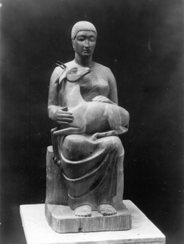 | Fig. 2 PEK0187  This wood carving is believed to have been carried out in King’s fifteenth year. Height: ~75cm  Photo: Peter King  Copyright: Estate

As well as a technical fluency in formal sculpture, largely self-taught prior to the consolidation of his skills at Wimbledon, King experimented with many materials, including Perspex stolen from a nearby factory. He appeared in court as a result, but apparently so intrigued the factory owner with the account of his technical innovations with the medium, charges were dropped. King also gained considerable skill with photography and amongst the surviving artefacts from his life is an extensive collection of glass plates recording his work. Figure 3 shows a commission for a school in Surrey, probably made before 1953. This photograph, found on page 44 of King’s notebook, is captioned in his hand ‘Stone relief on a Surrey County Council School 4ft x 5ft’.

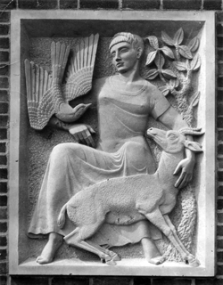 | Fig. 3 PEK1454  This photo is found on page 44 of King’s notebook, and is captioned in his hand ‘Stone relief on a Surrey County Council School 4ft x 5ft’ Another photo exists of the school building with the relief in place.  Photo: Peter King  Copyright: Estate

Once King moved into the Abbey Art Centre in 1951 or 1952 he was already pursuing a very personal experimentation and a move to abstraction. This early period of King’s work was dominated by two themes: figurative elements taken from ethnic art, and natural elements as in objet trouvé. By moving into the Abbey Art Centre he came into the orbit of its founder, Ohly, and his extensive collection of ethnic art from Africa, Indonesia, and Tibet. Some of his collection was on display in a converted tithe barn, an old structure directly opposite King’s studio. In the existing photographs King’s studio appears cramped and densely packed with finished and half-finished works. The photograph in Figure 4 was probably taken between 1951 and 1953, and shows a pair of figures on the left believed to have been assembled from found branches and timbers taken from an old carriage.

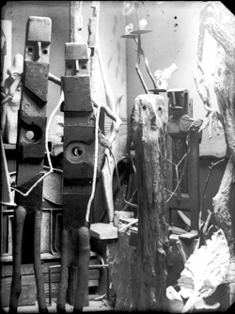 | Fig. 4 King’s Studio  This photograph, by King, probably taken between 1951 and 1953, show both the intensity at which he worked, and the dominant themes of that period. The pair of figures on the left is believed to have been assembled from found branches and timbers taken from an old carriage.  Photo: Peter King  Copyright: Estate

King had already made a journey from his assured classical mastery to the most experimental of formats, though probably still executing traditional commissions alongside his new experiments. His instincts for technical mastery were now often directed at the problems of metal-casting, using a home-made foundry in the garden of the Abbey Art Centre. He may have learned the lost-wax casting technique for small-scale sculpture from Alan Davie, a technique which King now adapted for larger-scale sculpture. He also used other flammable materials that would be lost in casting, including a bird’s nest carved into the shape of a face.

Other works of this period provide the bridge between the overtly experimental and the classical tradition in which he was so fluent, for example the torso shown in Figure 5. It shows the possible influence of both Moore and Hepworth.

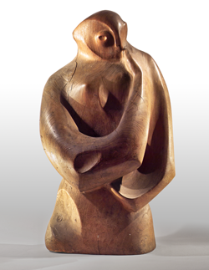 | Fig. 5 PEK0059  Torso in wood, 34 x 74 x 22 (cm)  Photo: Mike King  Copyright: Mike King

The early experiments with found materials and assemblages gave way to what could be called his mature or ‘middle-period’ style: sculpture in bronze, aluminium, stone and plaster with a consistent semi-relief treatment and a personal grammar of semi-geometrical abstraction. Generally considered to be the iconic piece of this period, and one of the few works with a name, Man with Cloak appeared on a Gallery One invitation (fig. 6). Typical of work of this period, the front is worked in detail, while the back is simply rounded off.

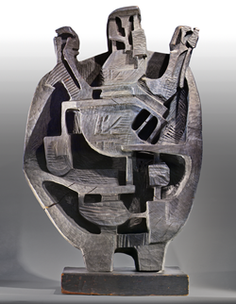 | Fig.6 PEK0001 (Man with Cloak)  Wood, 59 x 94 x 24 (cm)  Photo: Mike King  Copyright: Mike King

It is not clear why King moved from sculpting in the round to this semi-relief treatment, but his experience of formal relief work, and his extensive use of monotypes to explore his emerging sense of line, may have been factors. In fact he produced huge numbers of prints, mostly monotypes, of which many hundreds survive, and which were integral to his artistic development. The monotypes have a strong sculptural feel, complementing the frontal nature of the sculptures, and there are a number of examples of close relationships between print and sculpture. Figure 7 shows a monotype ‘sketch’ for the sculpture in Figure 8, which was King’s submission for the TUC Congress House sculpture competition in 1955. The number in the bottom-right corner may have been stamped there by competition officials. James Hyman has suggested that given its close resemblance the print came after the sculpture, but there is evidence from other print-sculpture pairings that it was the other way round.

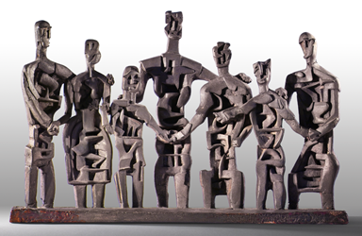 | Fig. 8 PEK0007  Composite (possibly armature plus painted clay), 52 x 34 x 9 (cm)  Entry for TUC Congress House sculpture competition  Photo: Mike King  Copyright: Mike King

Given the apparent convergence between from-the-front sculpture and in-the-round monotypes of this period, King’s next venture seems a natural step: to take his sculptural forms and use them in an animated film. His The Thirteen Cantos of Hell was an adaptation of part of Dante’s Divine Comedy, the purgatory section of which seemed to fascinate him. The technique he used was the shadow-puppet and rostrum technique of Reiniger, who taught him her methods in exchange for carpentry work he carried out on her rostrum stand. However her precise role as a possible mentor in animation is unclear. The Experimental Production Committee of the British Film Institute gave King a grant of £500 for the film and it was premiered the Hammer Theatre in May 1956, and shown at the National Film Theatre, the Edinburgh Festival, Cannes, and other European galleries. Figure 9 shows a still from the film, featuring a boat motif that appeared in much of his work of the period. It is poignant, in the light of his attempt on his life at the time, to note that The Thirteen Cantos of Hell ends with the ‘wood of the suicides’.

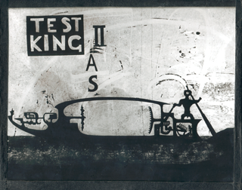 | Fig. 9 Film still  Film still, perhaps used in promotional material, from The Thirteen Cantos of Hell  Glass plate, 24 x 16 (cm)  Photo: Iby-Jolande Varga  Copyright: Iby-Jolande Varga

The ‘late’ period of his work seems to veer between a coherent culmination of his artistic trajectories, and nihilistic and anguished sculpture and paintings, one of the latter being completed in his own blood after slashing his wrists. His extensive journal entries in this period provide a picture of a mind on the verge of breakdown: brittle, intensively creative and profoundly anguished. Loader describes the period as a mutual exploration of Jung’s psychology and alchemical writings, resulting in another new direction for King: an illustrated book called The Ash of Mimir (fig. 12), a little reminiscent of Blake’s illuminated writings. In King’s notebook there are exercises in calligraphy as a preparation for this project, and some ruminations on the theme of ‘walking with a squint’ – seemingly a reference to the way that his surroundings could overwhelm him, and possibly a reference to Sartre’s Nausea which had clearly made an impact on him. He also describes suburbia as the ‘citadel of schizophrenia’, a phrase, it seems, of his own coinage, but hinting at his state of mind. Two factors seem to have precipitated this state of mind: firstly the genuine torment over the parting from his wife and two young children, and secondly the motorcycle accident in which he broke his leg. He made a poor recovery from this and was sent for endless and inconclusive medical tests.

Figure 10 is of a painting made in this last period, one of a series of over a dozen surviving works on paper depicting the human head in a paroxysm of anguish. These were often painted on the reverse of earlier monotypes, which, in some cases have been defaced, presumably by King in moments of anger or depression.

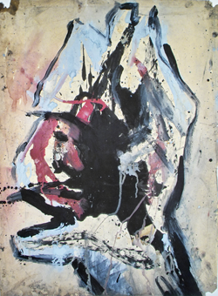 | Fig. 10 PEK0564  Paint on paper 56 x 76 (cm)  Photo: Mike King  Copyright: Mike King

His sculpture of the time was sometimes destructive in both design and execution. This was particularly so of work executed with a technique he had been working on for some time, of throwing molten metal into sand, and drawing into sculptural forms using a refractory implement. Musgrave had described this process as ‘action sculpting’ in a direct reference to Pollock’s action painting. Sir Anthony Caro mentions that in a visit to the Abbey Art Centre at this time, where he met Alan Davie and Peter King, he heard of a ‘new American painter called Jackson Pollock’ and adds that ‘Peter was far ahead of us all’. In a notebook King describes this rather immediate method of working in metal as follows: they were ‘produced by throwing the molten metal on a bed of fire-resisting material, and manipulating the metal before it sets. Each piece so produced is joined to the next by thrusting the solid form in the molten mass of the next one, so building up the desired structure’.

Figure 11 is of an aluminium piece built up in this way, but including another of his innovations: the addition of molten glass. This is one of the most considered thrown pieces of this later period, others seem to be more spontaneous and chaotic.

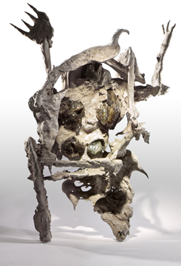 | Fig. 11 PEK0037  Figure, aluminium and glass, 24 x 37 x 17 (cm)  Photo: Mike King  Copyright: Mike King

King’s journal may provide some guidance as to the influences on him, though to mine its true significance a longer study than this is needed. The journal has no dated entries at all, though some of the books he refers to were only just in print during his last years, and may help pin down the earliest possible dates for some passages. A large section of the journal is devoted to a narrative and rather ironic account of a call up to National Service and subsequent training, interspersed with reminiscences of cinema attendance and other daily activities. There are also substantial sections of commentary on art, philosophy, religion, and psychology, which give us some idea of the thinkers he had studied. In philosophy, psychology and religion they were Lao Tse, Meister Eckhart, Henry Thoreau, Sigmund Freud, Jean-Paul Sartre, C. G. Jung, Martin Buber, Soren Kierkegaard, Martin Heidegger, Sarvepalli Radhakrishnan, Rudolf Lotze, Nikolai Berdyaev, Emmanuel Mounier, J. B. Coates, and Edward Glover. It seems that of all these it was Jung who was the most important to him. In art history and criticism they were Herbert Read and Lewis Mumford. The opening pages of the journal record King’s response to Herbert Read’s The Meaning of Art (1930) by. King is particularly interested in how distortion of geometric form works in aesthetics and how the degree of departure is ‘determined by the individual instinctive expression’.

At times it appears from the journal that King is embarrassed to be an intellectual: he ridicules intellectual activity as ‘fonting’. It is clear, however, that he must have read widely from an early age, and to some extent systematically. At the end of the journal, at a time that may not have been too long before his death, he had made a monthly reading list, indicating a determination to keep abreast of new writing in art criticism, literature and philosophy.

Apart from the narrative and commentary sections – sometimes interleaved – there are also three poems, and an extensive section towards the end on The Ash of Mimir (fig. 12). King was clearly obsessed with the Norse legend of Odin and his attempt to gain wisdom by hanging himself on the Ash of Mimir, the world-tree, also known as Yggdrasil. King states in the journal and on the frontispiece of The Ash of Mimir: ‘The Ash of Mimir may be defined as that process which will realise those fantasies of Transformation on Completion of a Journey.’ It is not clear what King’s sources are for the legend, though he may have first encountered the myth and its symbolism through Jung. He cites paragraph 523 from Jung’s Symbols of Transformation several times. The Ash of Mimir is an unfinished project consisting of five illuminated pages, twelve additional illustrations, and some twenty-eight journal pages of supporting text, though more related material may emerge in time. More work is required on the transcription and interpretation of these journal pages, but it is clear that King drew on the imagery of Jean-Paul Sartre’s Nausea in many descriptive passages.

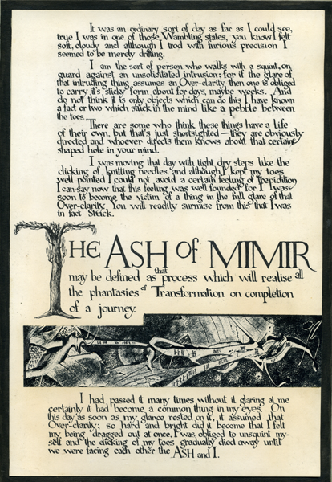 | Fig. 12 PEK0922 Frontispiece for The Ash of Mimir  Ink and monotype on paper, 20.18 x 29.24 (cm)  Photo: Mike King  Copyright: Mike King

This paper serves to amplify Harrison’s 2003 introduction to Peter King. The real work remains to form any significant conclusions concerning King’s life and work, to evaluate his place in British ’50s sculpture. Of the sculpture known to be lost but not necessarily destroyed there remains the possibility of their discovery, as well as hitherto unknown works. These may fill some of the gaps and help in the chronology. The journal and letters need careful cross-referencing with other accounts of King’s life, such as the written memoirs of his widow, and oral accounts from others still alive who knew him. A thematic study is required across the works on paper and the sculpture: once it is possible, for example, to see all the horse-related representations, or all the Stygian boats, collected together, much would emerge. King’s ability to so dramatically distort human proportions while retaining their integrity is also an issue worth pursuing across the collection: his personal grammar of human gesture is intimately related to this. At a purely technical level there are many unanswered questions as to whether he independently discovered some of the unusual metal-working techniques he deployed. Finally, the key questions of the influences on and by him will need to be resolved. As Harrison says, ‘it is hoped that appropriate recognition for this artist, now long overdue, will soon be forthcoming’. The scholarly work necessary for this recognition now has significant resources waiting to be explored.
(3726 words)

The author would like to thank the Art and Humanities Research Council (AHRC) for funding the digitisation project, and London Metropolitan University for support. The digitised archive is now online at the Visual Arts Data Service at vads.ahds.ac.uk/collections/PKA.html and at www.peterkingsculptor.org. ? At the time of writing there are over a thousand works recorded in the Peter King archive (available online via the Arts and Humanities Data Service); over a hundred items of memorabilia that help chart the course of his life and work; and a number of letters. The known works include 223 works and records of a further 123 that are either lost or destroyed; 618 works on paper; 45 puppets made of hinged card, many of which are weighted with lead; and two prints of the 16mm film The Thirteen Cantos of Hell. The exact dates of most works are not known, and he signed almost nothing and gave his pieces no names. At present they have only four-digit accession numbers. Hence there remains a considerable task to locate work within precise years and months, beyond the crude division presented here of four main periods.
A letter from the Contemporary Arts Society, dated 17 June 1997 states: ‘Further to your enquiry regarding the whereabouts of work by Peter King, the Contemporary Arts Society purchased the following work from the artist and presented it to the following museum collection. Series of Drawings, 1954 … Presented to Birmingham Museum and Art Gallery, 1959.’ (Letter in possession of the Estate of Peter King, hereafter Artist’s estate)
Starting with a mention in Roger Berthoud’s Life of Henry Moore (1987). This is now found in the revised edition: Berthoud, R., The Life of Henry Moore, London: Giles de la Mare Publishers, 2003, p. 303
Wedd, K., et al, Creative Quarters – The Art World in London from 1700 to 2000, Museum of London: Merrell, 2001, p. 135
Barker, I., Anthony Caro – Quest for the New Sculpture, Kunzelsau: Swiridoff Verlag, 2004
Mitchinson, D., et al, Hoglands – The Home of Henry and Irina Moore, Aldershot: Lund Humphries, 2007, pp. 73, 77, 90
Curtis, P., et al, Sculpture in 20th-century Britain Vol 2, Leeds: Henry Moore Institute, 2003, pp. 191-193
Recent shows include: Museum of London, ‘Creative Quarters’, June-July 2001; Henry Moore Institute, Leeds, ‘Sculpture in 20th Century Britain’, September 2003-March 2004; Modern British Artists, 20/21 British Art Fair, London, September 2006; Robin Katz Gallery, May-July 2007; Henry Moore Institute Library, Leeds, November 2007-January 2008; England and Co. Retrospective, March-April 2008; Abbey Art Centre, July 2008; British Museum, ‘British Sculptors’ Drawings’ from September 2008 to January 2009. Planned shows include Jonathan Clarke Fine Art, London, the Lotte Reiniger Museum, Tübingen, Germany, and a second solo show at England and Co.
Wedd, Kit, et al, Creative Quarters – The Art World in London from 1700 to 2000, (Museum of London) London: Merrell, 2001, p. 135
Robert Adams, Kenneth Armitage, Reg Butler, Lynn Chadwick, Geoffrey Clarke, Bernard Meadows, Eduardo Paolozzi and William Turnbull.
Letter from Frank Martin to Liz Sheppard, dated 26 February 1985; Henry Moore Institute Archive, Leeds
Barker, as at note 5, p. 50
King cast Caro’s Woman Walking Along and Acrobatic Figure, 1951-55, Barker, Ian, Antony Caro: Quest for the New Sculpture, Kunzelsau: Swiridoff Verlag, 2004, p. 59
Ibid., p. 59
The film is in the BFI Archive, London .
The Times, 5 November 1957
Letter from Caro to King’s widow, dated 1 November 1957, in Henry Moore Institute, Leeds, archive.
In 1993 George Melly wrote to King’s widow that he was impressed with photos of the work she had sent to him, letter to Katharine King, 29 March 1993, Artist’s estate
Some letters are in the Henry Moore Foundation Archive at Much Hadham, others in the Artist’s estate
This claim is made by King’s brother, but the only other evidence for this might be in King’s journal writings which bear a resemblance at times to Jean-Paul Sartre’s Nausea, alleged by Simone de Beauvoir to have been written after a bad mescaline trip.
Art News, February 1955, Vol. 53, No. 10, p. 68
Harrison, M., ‘Peter King’ in Curtis, as at note 7, p. 191
Another photograph exists of the school building with the relief in place, in notebook; artist’s estate.
As is well known the commission eventually went to Jacob Epstein and Bernard Meadows.
Private conversation.
Conflicting accounts of this event exist.
Private correspondence, 9 April 1997. See also Barker, as at note 11
King, journal, p. 14; Artist’s estate
The Peter King Estate is indebted to Betty MacAlister and Jackie Howson at the Henry Moore Institute, Leeds for the transcription of the journal.
King, journal, p. 1; Read, Herbert, The Meaning of Art, London: Faber and Faber, 1972, pp 28-32
A creature that intellectualises as a pastime is ridiculed by King as a ‘glub of font’ and compared to a grotesque insect that carries a huge egg sac around with it: King, journal, p. 77
King, journal, p. 98
Ibid, p. 96 and 100
Harrison, as at note 7, p. 193

